WEBSITE TRAFFIC ANALYSIS USING POWER BI

Internship Project Report
Submitted by: Priyadharshini S
College: KG College of Arts and Science
Department: B.Sc. Computer Science (Artificial Intelligence & Data Science)
Internship Company: Syntecxhub
Submission Date: 26-07-2026

ABSTRACT
This project focuses on analysing website traffic data using Microsoft Power BI. The main objective of this project is to understand website performance by analysing important traffic metrics such as users, sessions, engagement rate, event count, and average engagement time.
The dataset was cleaned, verified, and prepared before being imported into Power BI for analysis. An interactive dashboard was developed using various visualisations and Key Performance Indicators (KPIs) to represent website traffic behaviour effectively.
The dashboard helps in identifying the performance of different traffic channels, analysing user engagement patterns, and generating valuable insights. This project demonstrates how data analytics and visualisation tools can support organisations in making effective, data-driven business decisions.

1. INTRODUCTION
Website traffic analysis plays an important role in understanding online user behaviour and measuring the effectiveness of digital platforms. Organisations collect large amounts of website data to analyse how users interact with their websites and to improve their marketing strategies.
By analysing website traffic metrics, businesses can identify the sources that generate more visitors, understand engagement levels, and optimise their online presence. Traffic analysis helps organisations determine which marketing channels perform better and where improvements are required.
In this project, Microsoft Power BI was used to analyse website traffic data and create an interactive dashboard. The dashboard provides a visual representation of website performance using charts, KPI cards, and filters. It allows users to easily monitor important metrics and make better decisions based on data insights.

2. OBJECTIVES
The main objectives of this project are:
- To analyse website traffic performance using Power BI.
- To understand user behaviour through website metrics.
- To identify the most effective traffic acquisition channels.
- To evaluate user engagement using engagement-related metrics.
- To compare sessions and users across different channels.
- To create an interactive and informative Power BI dashboard.
- To generate useful business insights from website traffic data.

3. DATASET DESCRIPTION
The dataset used in this project contains website traffic information collected from different marketing channels. It includes details about website visitors, user engagement, sessions, and events.
Dataset Attributes
Attribute | Description
Session Primary Channel Group | Source or channel through which visitors accessed the website
Date + Hour | Date and time information of website activity
Users | Total number of website users
Sessions | Total number of website visits
Engaged Sessions | Number of sessions where users interacted with the website
Average Engagement Time per Session | Average duration of user engagement
Engaged Sessions per User | Average engaged sessions generated by each user
Events per Session | Average number of events performed during a session
Engagement Rate | Percentage of sessions that were engaged
Event Count | Total number of user interactions recorded

4. DATA CLEANING AND PREPROCESSING
Before performing analysis, the dataset was examined and prepared to ensure accuracy and consistency.
The following preprocessing steps were performed:
- Verified all column names and attributes.
- Checked the dataset for missing values.
- Identified and removed duplicate records if required.
- Verified appropriate data types for each column.
- Checked consistency of traffic channel names.
- Ensured the dataset was ready for analysis.
- Imported the cleaned dataset into Microsoft Power BI.
After performing data validation, the dataset was found to be suitable for creating visualisations and generating insights.

5. TOOLS AND TECHNOLOGIES USED
The following tools were used for completing this project:
Microsoft Excel
Used for initial dataset inspection, data cleaning, and validation.
Microsoft Power BI
Used for data modelling, creating visualisations, developing dashboards, and analysing website traffic performance.
Microsoft Word
Used for preparing and documenting the internship project report.
GitHub
Used for storing and managing project-related files and documentation.

6. DASHBOARD OVERVIEW
An interactive dashboard was created using Microsoft Power BI to analyse website traffic performance.
The dashboard contains multiple visual elements that provide a clear understanding of website activity.
KPI Cards
The following Key Performance Indicators were included:
- Total Users
- Total Sessions
- Total Event Count
- Average Engagement Rate
Visualisations
The dashboard includes the following charts:
- Sessions by Channel
- Users by Channel
- Event Count by Channel
- Average Engagement Rate by Channel
- Average Engagement Time by Channel
- Events per Session by Channel
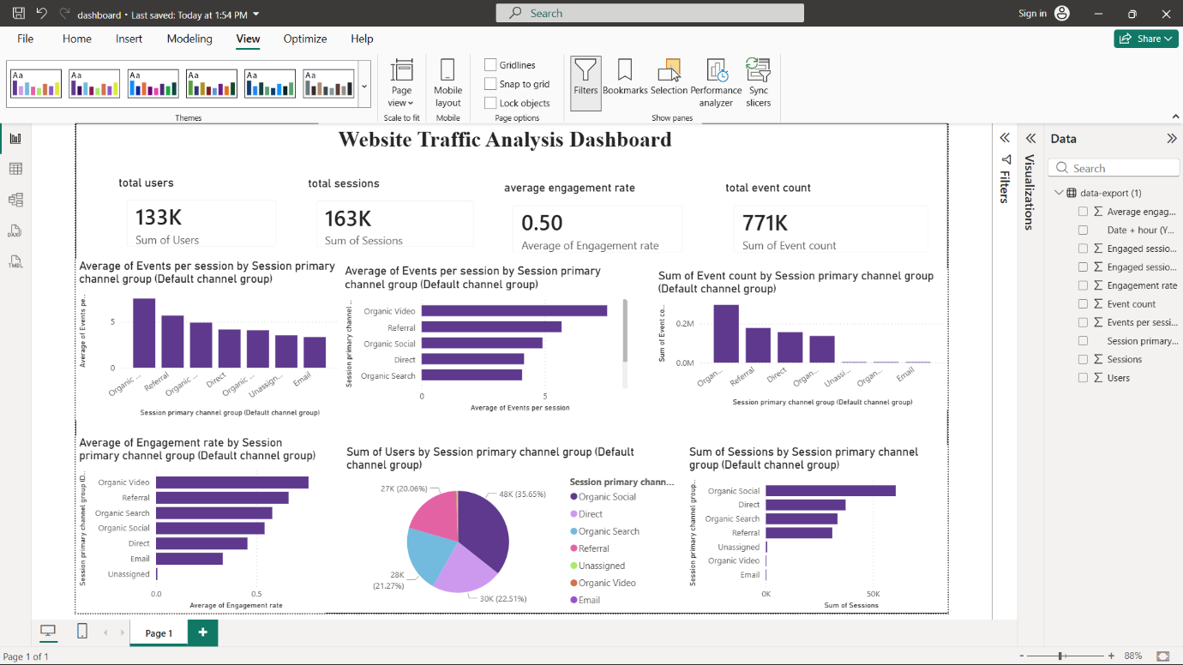

7. DATA ANALYSIS
The developed Power BI dashboard provides an effective overview of website performance by analysing different traffic metrics.
The analysis compares users, sessions, engagement rate, event count, and average engagement time across different acquisition channels. These comparisons help identify which channels contribute more towards website traffic and user interaction.
The interactive dashboard enables users to filter specific channels and analyse their performance individually. This makes the process of understanding website behaviour easier and helps in identifying areas that require improvement.
Through visual analytics, large volumes of website data can be converted into meaningful information that supports better decision-making.

8. BUSINESS INSIGHTS
Based on the analysis performed using the Power BI dashboard, the following insights were identified:
- Different traffic channels contribute differently to overall website performance.
- Certain channels generate higher numbers of users and sessions compared to others.
- Engagement rates vary depending on the traffic source.
- Event count helps measure the level of interaction performed by website visitors.
- Channels with higher engagement rates provide better opportunities for business growth.
- Lower-performing channels require optimisation and improved marketing strategies.
- Regular monitoring of website traffic helps organisations improve their digital performance.
- Interactive dashboards make complex data easier to understand and analyse.

9. RECOMMENDATIONS
Based on the analysis results, the following recommendations are suggested:
- Increase focus on high-performing traffic channels.
- Improve marketing strategies for channels with lower performance.
- Create engaging website content to improve user interaction.
- Regularly monitor website traffic using Power BI dashboards.
- Use data-driven insights for future marketing campaigns.
- Analyse user behaviour continuously to improve website performance.

10. CONCLUSION
This project successfully analysed website traffic data using Microsoft Power BI. The interactive dashboard developed in this project provides valuable insights into website users, sessions, engagement rate, and event activities.
The project demonstrates the importance of data analytics and visualisation in understanding user behaviour and evaluating digital performance. Power BI helps transform raw website data into meaningful information through interactive reports and dashboards.
The analysis supports organisations in making informed decisions, improving marketing strategies, and enhancing overall website effectiveness.

11. FUTURE SCOPE
The project can be enhanced further with additional analytical features such as:
- Real-time website traffic monitoring.
- Predictive analytics using machine learning techniques.
- Geographic analysis of website visitors.
- Conversion rate and sales analysis.
- Customer segmentation for personalised marketing.
- Integration with live website analytics platforms.

